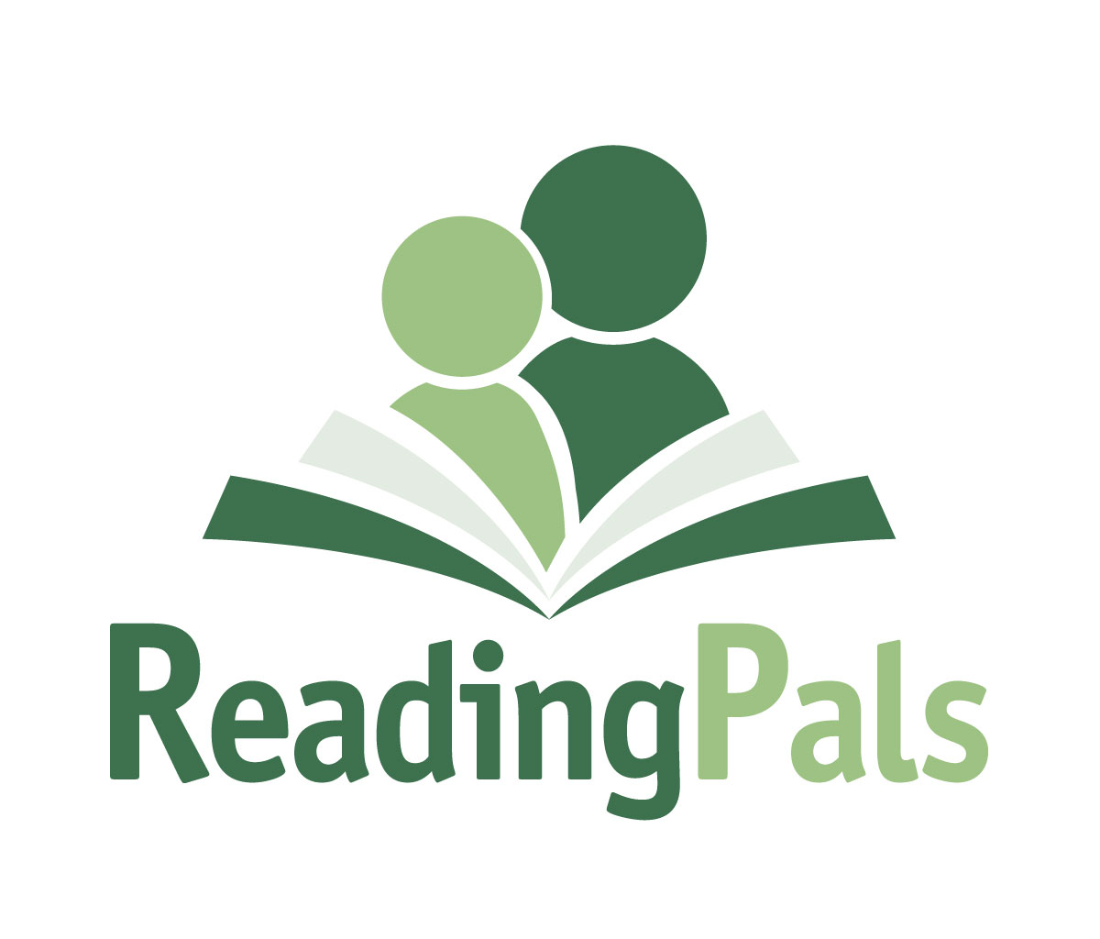
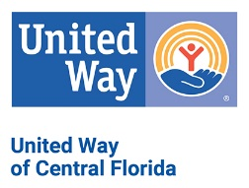
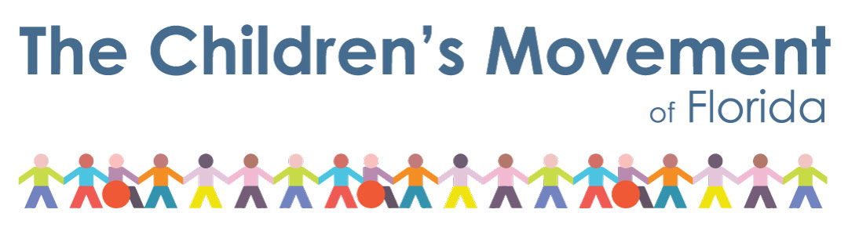
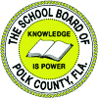

UWCF ReadingPals Polk County Volunteer Application
For New ReadingPals Applicants
2021/2022 School Year

Thank you for your commitment to serve as a ReadingPals school volunteer!

ReadingPals is a Statewide Early Literacy Initiative
"ReadingPals offers volunteers an opportunity to build meaningful relationships with young children in Florida, while helping them improve their social-emotional development and early literacy skills. ReadingPals is managed by The Children’s Movement of Florida and administered through 17 United Ways — with the help of numerous community partners across the state.”

Please complete this paper application and send to readingpals@uwcf.org, or mail to P.O. Box 1357, Highland City, FL 33846-1357.

*Last Name: Click or tap here to enter text. | * First Name: Click or tap here to enter text. | M.I.: Click or tap here to enter text.

*Date of Birth (including year): Click or tap to enter a date. | *Ethnicity: Click or tap here to enter text. | Gender: Click or tap here to enter text.

*Street: Click or tap here to enter text. *City: Click or tap here to enter text. *State: Click or tap here to enter text.

*Zip Code: Click or tap here to enter text. *Email: Click or tap here to enter text.

*Home Phone: Click or tap here to enter text. *Cell Phone: Click or tap here to enter text.
*Required Information for all ReadingPals (Please type or print)

Your Preferences
Please check the school(s) where you would prefer to volunteer marking preference 1st choice, 2nd, etc.

☐Crystal Lake Elementary ☐ Highland City Elem ☐ Lake Shipp Elementary
700 Galvin Drive 5355 9th Street, SE 250 Camellia Drive
Lakeland, FL 33801 Highland City, FL 33846 Winter Haven, FL 33880
M, T, Th, F at noon M, T, W, Th, F at 8:00 am M, T, Th, F at 8:45am

☐ Lewis A Woodbury Elem. ☐ North Lakeland Elem.
115 South Oak Avenue 410 W. Robson Street
Fort Meade, FL 33841 Lakeland, FL 33805
M, T, W, TH at 8 00am T, W, Th, F at 1:40 or 1:45pm

Please check the day(s) you would like to volunteer marking preferences 1st choice, 2nd, etc.
Choose an item.MondayChoose an item.TuesdayChoose an item.WednesdayChoose an item.Thursday
Choose an item.Friday

Mentor to Make a Difference / Three Pillars of ReadingPals
Mentor: To build genuine impactful relationships between students and our volunteer mentors.
Social-Emotional: To help students build a strong social-emotional foundation through self-awareness, self-management, social awareness, relationship skills and responsible decision making.
Early Literacy: To improve students’ understanding of the fundamental building blocks of early literacy.

Background Check
The School Board of Polk County requires volunteer applicants to undergo a Florida Department of Law Enforcement criminal background. Get Involved | Polk County Public Schools (polkschoolsfl.com) .
Instructions:
- There is a $25 non-refundable fee for the required criminal background screening. (Note: Approved volunteer status is good for 5 years.) You will be asked to make the payment during the online application process.
- The Polk County School Board requires all volunteers to fill out an application online at Get Involved | Polk County Public Schools (polkschoolsfl.com) .
- Pictures for security badges will be taken at your assigned school and picked up there.
- All information will remain confidential.
- The United Way of Central Florida reserves the right to accept or deny applicants to any affiliated volunteer program.

If you have been convicted of murder, sexual offenses such as sexual battery, lewd or lascivious acts, soliciting lewd acts or indecent exposure, sexual misconduct, prostitution or solicitation of prostitution, obscenity, or pornography, contributing to the delinquency/dependency of a child, abuse/neglect, drug related charges, kidnapping or battery to a child, criminal driving offenses, you will not be approved.

ReadingPals was designed by and is currently managed by The Children’s Movement of Florida – a nonprofit, nonpartisan movement of Floridians advocating for high-quality early learning opportunities, access to children’s health care, and parent support programs. Through your volunteer experience, you will see firsthand the importance of high-quality early education and why The Movement wants to give our youngest Floridians a strong start.

_____ Yes! Please share my email address with the Children’s Movement so I can begin receiving updates directly from The Movement on statewide ReadingPals efforts and what is happening in early education in Florida.

Signature: _____________________________________________ Date: _________________________

The School Board of Polk County, Florida, prohibits all forms of discrimination and harassment based on race, color, sex, religion, national origin, marital status, age, homelessness, or disability or other basis prohibited by law in any of its programs, services, activities, or employment. To file your concerns, you may contact the Office of Equity & Compliance in the Human Resource Service Division at (863)534-0513

For more information, go to uwcf.org and click on Our Work, Education, Helping Kids Succeed, then ReadingPa

Office Use Only:
Andar: __________ Trained: ___________ Approved: ___________ Vol. Status Expire Date: ______________________

