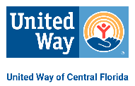
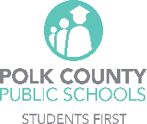
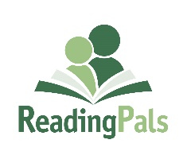
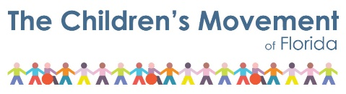

UWCF ReadingPals Polk County Volunteer Application
For New ReadingPals Applicants (2 pages)
2023/2024 School Year

Thank you for your commitment to serve as a ReadingPals school volunteer!

ReadingPals is a Statewide Early Literacy Initiative
"ReadingPals offers volunteers an opportunity to build meaningful relationships with young children in Florida, while helping them improve their social-emotional development and early literacy skills. ReadingPals is managed by The Children’s Movement of Florida and administered through 15 United Ways and affiliate organizations— with the help of numerous community partners across the state.”

Please complete this paper application and send to readingpals@uwcf.org, or mail to P.O. Box 1357, Highland City, FL 33846-1357.

*Last Name: Click or tap here to enter text. | * First Name: Click or tap here to enter text. | M.I.: Click or tap here to enter text.

*Date of Birth (including year): Click or tap to enter a date. | *Ethnicity: Click or tap here to enter text. | Gender: Click or tap here to enter text.

*Street: Click or tap here to enter text. *City: Click or tap here to enter text. *State: Click or tap here to enter text.

*Zip Code: Click or tap here to enter text. *Email: Click or tap here to enter text.

*Home Phone: Click or tap here to enter text. *Cell Phone: Click or tap here to enter text.
*Required Information for all ReadingPals (Please type or print)

Please check the school(s) and circle the day(s)/time that you would prefer to volunteer marking 1st choice, 2nd, etc. Note: The ReadingPals schools/hours may be subject to change as they are fully confirmed later in the summer for the upcoming school year.

☐ Alta Vista Elementary ☐ Auburndale Central Elementary ☐ Crystal Lake Elementary
Haines City 33844 Auburndale 33823 Lakeland 33801
M, T, W, Th – 9:00 – 10:00 am M, T, W, Th - 8:05-9:05 am M, T, W, Th – 8:15-9:15 am

☐ Dixieland Elementary ☐ Elbert Elementary ☐ Highland City Elementary
Lakeland 33803 Winter Haven 33881 Highland City 33846
M, T, W, Th – 9:00-10:00 am M, T, W, Th - M, T, W, Th - 8:10-9:10 & 9:10-10:10 am

☐ Jesse Keen Elementary ☐ Lake Shipp Elementary ☐ Lewis Elementary
Lakeland 33815 Winter Haven 33880 Ft. Meade 33841
M, T, W, Th - 1:45-2:45 pm M, T, W, Th – 8:30-9:30 am M, T, W, Th - 8:05-9:05 am

☐ Padgett Elementary ☐ Polk Avenue Elementary ☐ Purcell Elementary
Lakeland 33809 Lake Wales 33853 Mulberry 33860
M, T, W, Th – 9:10-10:10 am M, T, W, Th - 9:20-10 20 am M, T, W, Th – 8:30-9:30 am

☐ Stephens Elementary ☐ Willow Oak Elementary
Bartow 33830 Mulberry 33860
M. T, W, Th – M, T, W, Th – 8-9 am & 9-10 am

Mentor to Make a Difference / Three Pillars of ReadingPals
Mentor: To build genuine impactful relationships between students and our volunteer mentors.
Social-Emotional: To help students build a strong social-emotional foundation through self-awareness, self-management, social awareness, relationship skills and responsible decision making.
Early Literacy: To improve students’ understanding of the fundamental building blocks of early literacy.

Background Check
The School Board of Polk County requires volunteer applicants to undergo a Florida Department of Law Enforcement criminal background. Get Involved | Polk County Public Schools (polkschoolsfl.com) .
Instructions:
- There is a $25 non-refundable fee for the required criminal background screening. (Note: Approved volunteer status is good for 5 years.) You will be asked to make the payment during the online application process.
- The Polk County School Board requires all volunteers to fill out an application online at Get Involved | Polk County Public Schools (polkschoolsfl.com) .
- Pictures for security badges will be taken at your assigned school and picked up there.
- All information will remain confidential.
- The United Way of Central Florida reserves the right to accept or deny applicants to any affiliated volunteer program.

If you have been convicted of murder, sexual offenses such as sexual battery, lewd or lascivious acts, soliciting lewd acts or indecent exposure, sexual misconduct, prostitution or solicitation of prostitution, obscenity, or pornography, contributing to the delinquency/dependency of a child, abuse/neglect, drug related charges, kidnapping or battery to a child, criminal driving offenses, you will not be approved.

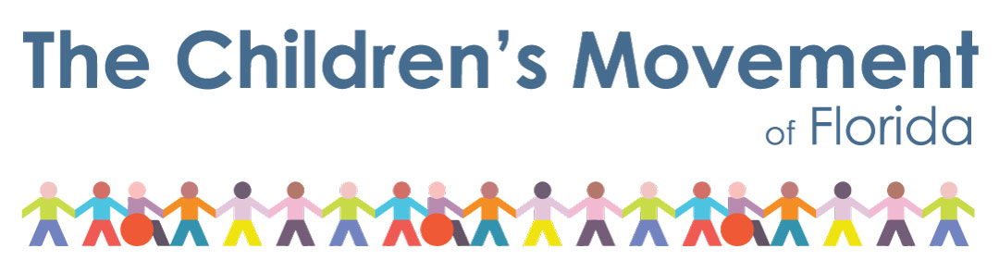
ReadingPals was designed by and is currently managed by The Children’s Movement of Florida – a nonprofit, nonpartisan movement of Floridians advocating for high-quality early learning opportunities, access to children’s health care, and parent support programs. Through your volunteer experience, you will see firsthand the importance of high-quality early education and why The Movement wants to give our youngest Floridians a strong start.

_____ Yes! Please share my email address with the Children’s Movement so I can begin receiving updates directly from The Movement on statewide ReadingPals efforts and what is happening in early education in Florida.

If have been a ReadingPal in the past -
Please share the years that you volunteered in the program __________ - ___________.
Do you still have your copy of the ReadingPals Training Notebook? Yes No

Signature: _____________________________________________ Date: _________________________

The School Board of Polk County, Florida, prohibits all forms of discrimination and harassment based on race, color, sex, religion, national origin, marital status, age, homelessness, or disability or other basis prohibited by law in any of its programs, services, activities, or employment. To file your concerns, you may contact the Office of Equity & Compliance in the Human Resource Service Division at (863)534-0513

For more information, go to uwcf.org and click on Get Involved, Volunteer, then scroll down and click on ReadingPals

Office Use Only:
Andar: __________ Trained: ___________ Approved: ___________ Vol. Status Expire Date: ______________________

